**Visualizing CO2 vs Temperature data**

**Team member names: -**

Parth Patel: - ppatel92@gatech.edu

Shafiq Mohammed: - shafiq@gatech.edu

**Problem Description: -**

Building an interface that visualizes CO2 and temperature data associated with each state for the US, in a manner that allows a user to observe the relationship between CO2 and temperature change ranging from 1990 to 2012. The problem can be broken down into three aspects that we have focused on: -

Domain: The domain that we are targeting for this project is the relationship between a state’s CO2 emissions and the changes observed in the weather for that state over time. The dataset found during our initial research allows us to target this domain as it shows data of emissions associated with each state. The next set of data shows the temperature associated with each state over the two decades. This visualization will primarily be targeted towards scientific research performed in the field of different types of CO2 emissions and their effect on the atmosphere.

Task: - The visualization should be able to provide tools to a user with which he can compare and summarize different pieces of information associated with each state and observe changes in weather trends correlated with the CO2 emissions generated by each state over time. For example, the user will either be able to observe a static temperature in a specific year for a state or for all states, or the user can observe a trend, a change in weather for all states over a time series representation of the data. The user can compare a trend observed in CO2 emissions by each state over 2 decades, and compare that to a trend observed in climate for each state to summarize if CO2 emissions affect climate.

Dataset: The dataset contains numerical values of CO2 emission for each state in the US, ranging from 1990 to 2012. This dataset will allow us to determine which state have the highest or lowest CO2 emission, which will allow us to map the data with those from temperature value. The temperature values are in a different file with the same format and are associated with each state in the US, ranging from 1990 to 2012.

**Screen Shots: -**

**Temperature Data**

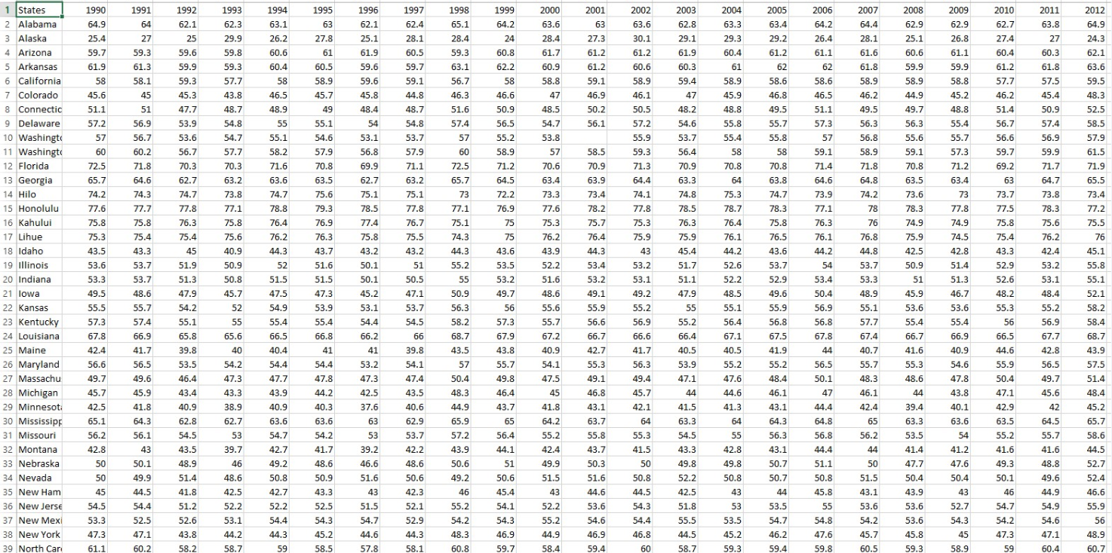

**CO2 Data**

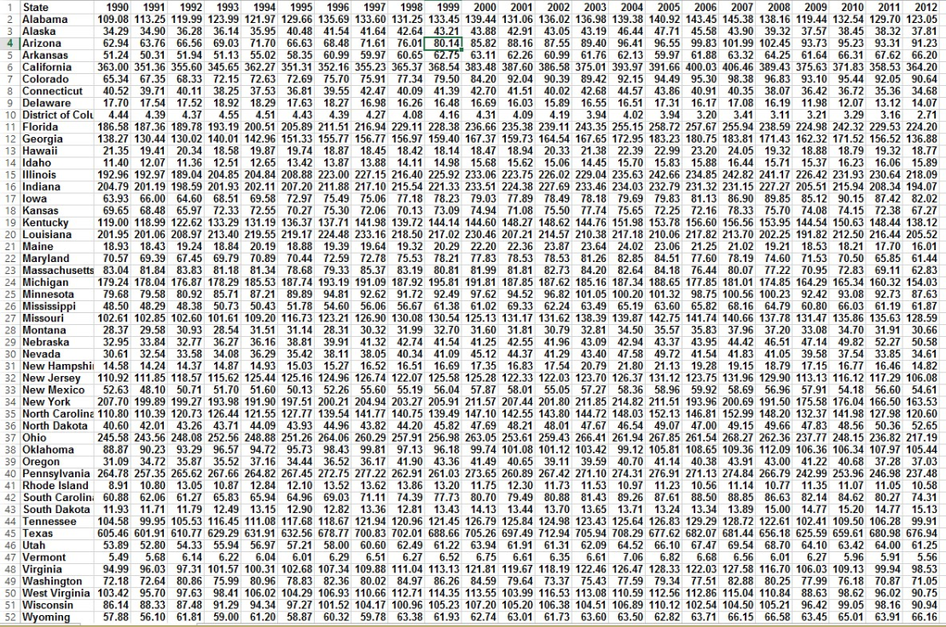

**Interface: -** <http://jsfiddle.net/8zx3ghnn/26/show/> and code : - http://jsfiddle.net/8zx3ghnn/26/

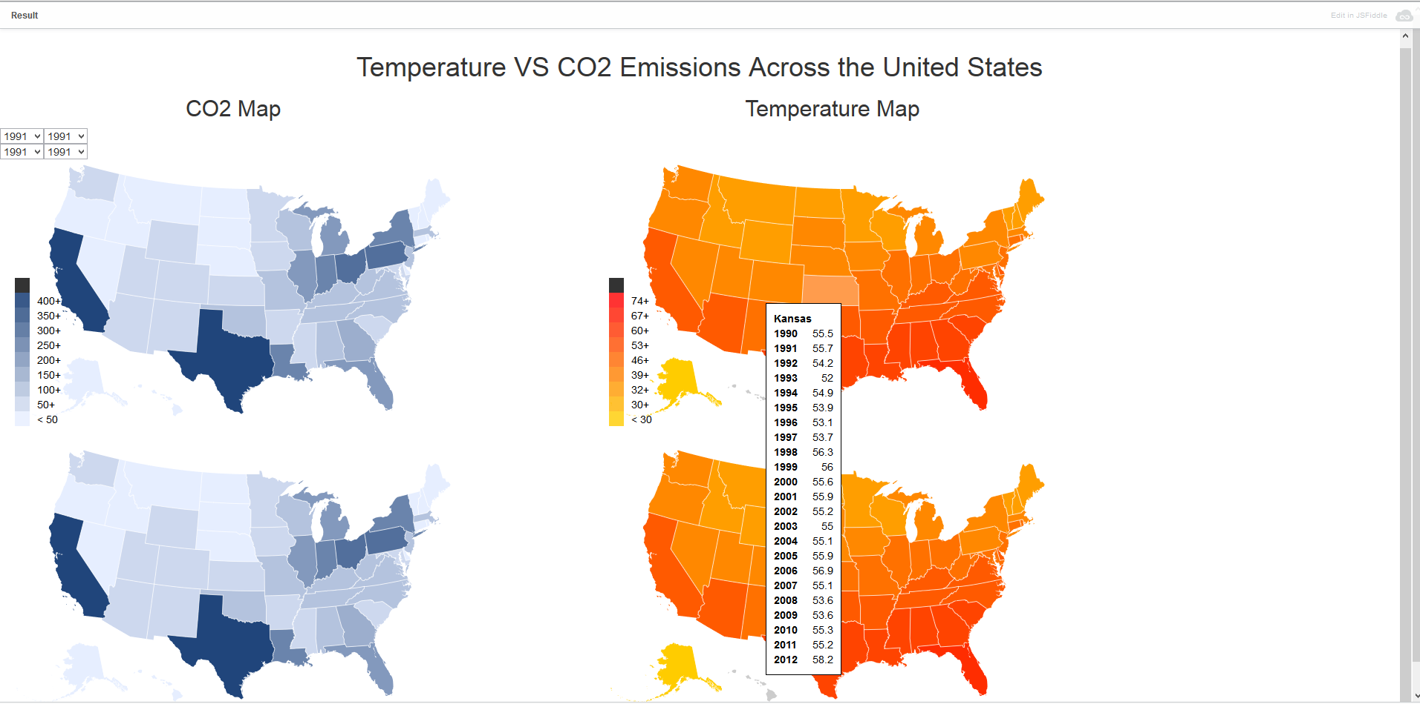

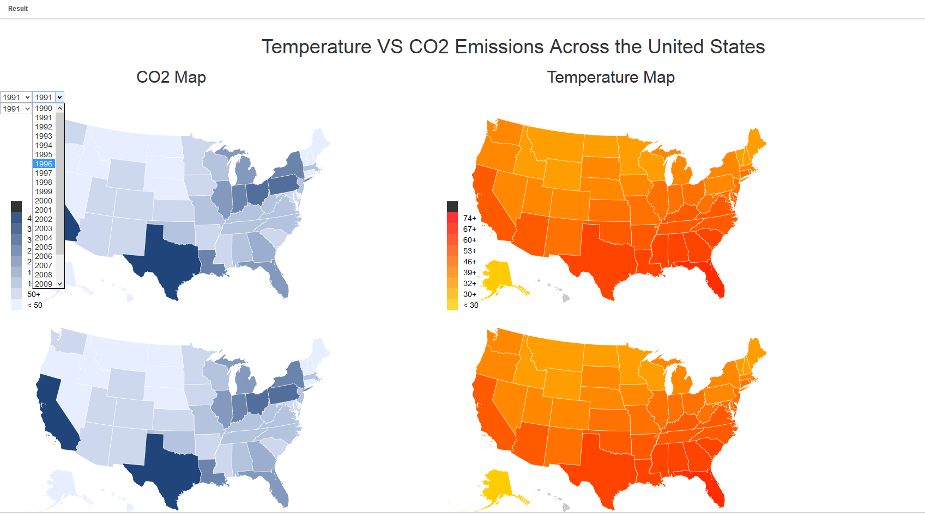

**Interface Description: -**

The idiom chosen encodes values of CO2 and temperature for each state by using a light to dark color scale on four different choropleth maps: two for CO2, two for temperature. We used the rule of thumb of “Get it right in black and white” as a basis for our encoding. Initially, we were considering with going with a double line graph. However, since we ran out of screen real estate, we decided to come up with another way of representing a similar type of data. Thus we decided to encode a hovering table that is dynamically displayed when the user hovers over a state, which displays the values over a range of years, as per Ben Shneiderman's mantra “Overview First, Zoom and Filter, Detail on Demand”, except we did not have anything to zoom on. Our chosen idiom manages the complexity of the data by mapping the values to a percentage of the two color choices we picked for each graph. This way, when a higher value is displayed, the luminance decreases and results in a darker shade of the state. However, when a lighter value is displayed, the luminance increases and results in a lighter shade of the state. A user can also select a specific year from the dropdowns provided for each choropleth map which are easily accessed from the upper left corner of the screen, and are positioned to mimic the positioning of the choropleth maps themselves. Thus, a user cannot get confused in terms of associating changes made to the maps. While designing the dropdown selectors, we kept the read-flow principle in mind--since the user will start reading from the left, we decided to position the selectors at the left so the user can select those first before doing anything else.